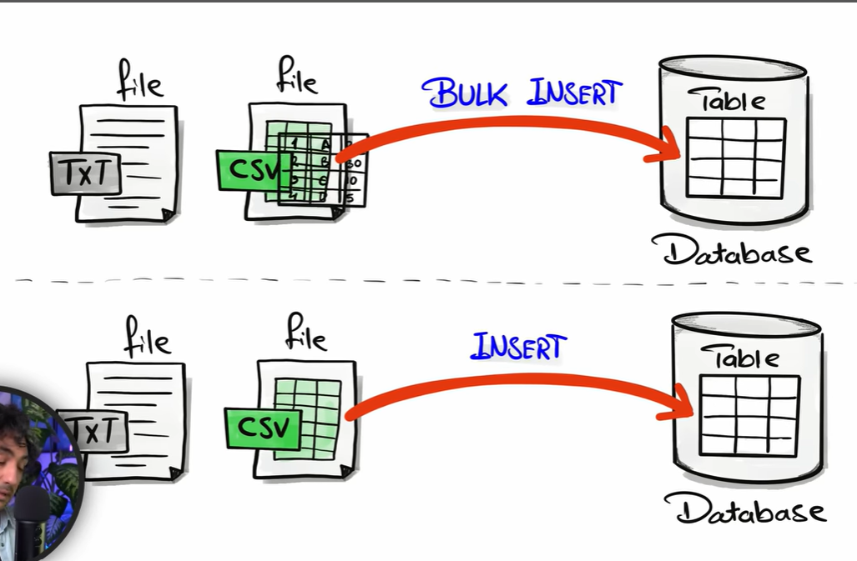

Please run the below script in here :-
\Reference\scripts\bronze\proc_load_bronze.sql

